Walking Out of the Anthropocene:
The Affordances of Arts-based and Indigenous Pedagogies

Introduction

The past few decades have revealed numerous rationales for the urgent necessity of implementing sustainability education that considers both global and local contexts. Universities have developed faculties and departments that offer a variety of degree programs in this field, and many faculties of education offer environmental or sustainability foci as part of their wider degree offerings creating an ever increasing capacity for delivering messages about environmental education and sustainability. Many school systems, however, have failed to create adequate space (philosophically and in curriculum) to realize the effective inclusion of sustainability within larger school discourses. We suggest that the recent turn of global events presents an opportunity to loosen the roots of older curricular concerns. To support this momentum we offer here several key considerations that have emerged from our collaborative educational efforts over the past ten years.

Before proceeding, we feel it is important to acknowledge our geographical and social locations as a way to ground the work in the pedagogies we aim to discuss. Shannon Leddy is an Assistant Professor (Teaching) at the University of British Columbia. She is Mètis on her father’s side and Irish Canadian on her Mother’s, originally from Saskatoon (Treaty Six Territory) and has lived on the traditional and unceded land of the Musqueam, Squamish and Tsleil-Watuth nations since 1994. David Zandvliet is a (settler) Professor in the Faculty of Education at Simon Fraser University who currently resides on Sto:lo territory. He has worked in a number of Indigenous communities and is deeply interested in bio-cultural diversity and the links between culture and environment in the diverse communities where he works. To begin this way is important to our pedagogy. To acknowledge our positionality in relation to the lands we have come from and the lands we are on is the first step in moving towards a decolonized iteration of environmental education. It reminds us that our positions are inherently political and we must therefore always endeavour to work in a politic manner.

In our working relationship, spanning a decade, we have always circled the area of environmental education, David bringing his background in elementary and post-secondary science education and as a leader in ecological and place-based education, and Shannon bringing her background in Arts education, along with Indigenous knowledges and sensibilities. We work collaboratively with both teacher candidates and graduates students, and facilitate field trips to a variety of ecologically relevant sites. Through our work several key themes have emerged time and again, which we wish to explore further here as a means of opening new discussions within the field of environmental education.

First, the inclusion of Indigenous knowledges is profoundly important if this work is to be truly relevant. This means including Indigenous voices in course readings and curriculum, and creating opportunities to connect students with knowledge keepers and community members. Second, learning to understand the land through the geographic lens of stratification creates an opportunity to see land beyond resource, commodity or recreation, and offers an opening to the notion of the land as our first teacher. Third, using circle pedagogy within our work creates the conditions necessary for both true democracy and for placing our collective humanity back at the centre of our work. And fourth, the inclusion of analogue skill development through art making practices fosters connection to our bodies and senses and the opportunity to balance academic rigour with a playfulness that facilitates more deeply connected learning.

Some initial context

The field of education on Indigenous Knowledge (IK) has grown rapidly in the last decades, led by noted scholar Gregory Cajete (1994; 1999). More recently Gregory Lowan-Trudeau (2013) outlined an ‘indigenous environmental education’ noting that its emergence has paralleled a growing trend in North America and other parts of the world seeing a dramatic rise in “programs teaching indigenous knowledge and philosophies for the benefit of indigenous and nonindigenous students” (Lowan-Trudeau 2013, p. 404).
A number of earlier themes in EE have also made strong links with Indigenous education. Most notably, the work of Gloria Snively (2009) and Gregory Cajete (1994) are examples of programs at the crossroads of Western and Indigenous approaches to environmental education.
In Look to the Mountain (1994) Cajete stated that if the current emphasis on Western oriented curricula continued, the indigenous way of life would be further eroded. He also pointed to a need for balanced integration of both Indigenous and Western forms of education. Cajete’s work is valuable in reminding us that while modernity may bring innovation, it is often accompanied by a loss of community. In his view, Indigenous culture should be viewed as a complex intertwining of both community and place (Lowan-Trudeau 2013).
In support of our approach we agree that the ancient roots of IK, as argued by Winona LaDuke (2002), hold a wealth of ignored knowledge of ecological systems that would benefit resource management and ecosystem protection in North America:
Frankly, these native societies have existed as the only example of sustainable living in North America for more than 300 years … (p.78)
Cajete (1999) claimed that this deep connection to place in indigenous culture resulted in “Indigenous people [feeling responsible for not only themselves], but also for the entire world around them” (p. 11). This links directly to the tension between the Western attachment to individualism and the Indigenous tendency towards collectivism, and points to one of the disconnections we sometimes encounter in our work where Indigenous ontologies are concerned. The critical lens on Western approaches to education inherent in Indigenous education and the value given by Indigenous cultures to Traditional Ecological Knowledge (TEK) also link strongly to the theoretical foundations of a critical place-based form of education (Gruenewald 2003), in which we encourage our students to see beyond the immediate history of Canada to the deeper history of the land.
Ecological Frameworks

Complementary to Indigenous forms of education, ecological frameworks used in our programs offer a critique of the mainstream organization of curricula while at the same time making a case for alternative place-based pedagogies that allow teachers to interpret curriculum in a way that nestles learning within the context of a physical and cultural community. Teaching with/in this framework focuses on attempts to improve the quality of life within communities while at the same time assisting students and teachers to develop a sense of ‘their place’ within them. While others make arguments for place-based or community-based models of learning, our practices attempt to take this further by describing the need for critical embodied approaches in their implementation. Central to this is the idea that an ecological framework for education identifies many taken-for-granted assumptions about teaching. These are best enacted when our actions are deeply embedded with/in the complexity of real environments and communities.

The notion of a place-based education has been well described by David Sobel (1993) and related ideas have been expanded on by others such as Gruenewald (2003) and Hutchison (2004). The difficulty in describing exactly what would constitute a place-based education becomes clouded partly due to the multiple and interdisciplinary nature of the literature where this notion seems to reside. Grunewald (2003) wrote that the idea of place-based learning connects theories of experiential learning, contextual learning, problem-based learning, constructivism, outdoor education, Indigenous education and environmental education. More recently, Herman Michell (2018) has published on land-based education from his perspective as a Nehiyaw (Cree) scholar. While rich in the same connections to experiential and constructivist learning, his offering also speaks deeply to the importance of contextual learning in relation to cultural specificity, centering Indigenous ontologies and epistemologies at the centre of place.

In arguing for what he describes as a critical pedagogy of place, Grunewald (2003) relates that our educational concern for local space (community in the broad sense) is sometimes overshadowed by both the discourse of accountability and by the discourse of economic competitiveness to which it is linked. In our opinion, place becomes a critical construct to its opponents not because it is in opposition to economic well-being, but because it challenges assumptions about the dominant ‘progress’ metaphor and its imbedded neo-conservative values. An ecological framework seeks to discard a one-sided view of progress by taking as its first assumption education ‘about’ and ‘for’ defined communities. Ecological education denotes an emphasis on the inescapable ‘embeddedness’ of humans and their technologies in natural systems. Rather than seeing nature as ‘other,’ ecological education involves the practice of viewing humans as one part of the natural world and human societies and cultures as an outgrowth of interactions between our species and particular places (Smith & Williams, 1999).

Indigenous Inclusion Matters

Shifting the focus in environmental education does not call for a complete disregard of the Western ways of knowing that have dominated this developing discourse thus far. It is a call for a new paradigm, certainly, but one that attends to ethical relationality (Donald, 2009). That is, we need to learn to walk in both Indigenous and Western ways, to acknowledge and work between differences, to triangulate ourselves towards a third space. We link this also to the work of Mi’kmaw Elders Murdena and Thomas Marshall (Bartlett, C., Marshall, A. & Marshall, T., 2012) and their concept of etuaptmumk or Two-Eyed Seeing, which “is the gift of multiple perspective treasured by many aboriginal peoples and explains that it refers to learning to see from one eye with the strengths of Indigenous knowledges and ways of knowing, and from the other eye with the strengths of Western knowledges and ways of knowing” (p. 335). The facilitation of both two-eyed seeing and ethical relationality, however, first require that the ontological nature of our differences be understood.

In teasing out the ontological roots of Western conceptualizations about land, Gardner Seawright (2014) points to the underlying Lockean philosophy that seems to inform much Western eco and place-based pedagogy. Indeed, the philosophical underpinnings of colonization rest on the certainty that land is first and foremost a resource, commodifiable, and best placed in the hands of ideal (white Western) social players. It is a perspective that fed the mercenary and extractive missions of early European arrivals, and ultimately paved the way for total occupation. His thesis is that this precept enforces tacitly held assumptions about white supremacy, which further informs policies and practices around land usage that limit access to land ownership and development, and which mirror the classist and racist status quo.

Take, for example, in the newly formed Dominion of Canada, the 1911 creation of the Dominion Forest Reserves and Parks Act, which paved the way for the creation of Canada’s National Parks. This Act speaks clearly to the intention for the land to be preserved for the enjoyment of Canadians. This position underscores the deliberate colonial erasure of Indigenous relationships with the land, and fixed in the national imagination the notion that land that cannot be made profitable through farming and other work should be viewed as recreational. Divorced from its history of Indigenous stewardship and presence, the land is rebranded as the rightful inheritance of those now called Canadians. Most tellingly, at this point in history, through the mechanism of the Indian Act of 1876, Indigenous peoples were not considered to be Canadian citizens, but rather wards of the state (Joseph, 2015; Vowel, 2016).

After more than one hundred and fifty years of narratives about the land that focussed on productivity and recreation, it can be challenging to see beyond the limitations of this way of thinking. Certainly, environmental education is rooted in the concern for the ecological wellbeing and protection of all species. But as the decades have passed since Rachel Carson’s work came to light, the view of land as a recreational commodity has created even more complexity around our understanding of land and place. It is for this very reason that the inclusion of Indigenous perspectives on land are crucial to expand this discourse. Wildcat et. al. (2014) suggest that “Land-based education, in resurging and sustaining Indigenous life and Knowledge, acts in direct contestation to settler colonialism and its drive to eliminate Indigenous life and Indigenous claims to land” (p. III). This does not mean that settlers are to be excluded from this old/new way, but simply that many will need to reconsider, or perhaps consider for the first time, their relationship to the land on which they live.

Métis scholar Jennifer Adese (2014) draws on her extensive research into Métis literatures and histories to foster her understanding of what comprises a Métis world view. She evokes the notion of wahkootowin (Michif) or wahkotowin (Nehiyaw/Cree), which refers to the interrelatedness of all living beings and of all natural elements in the world. This concept is central to reimagining how we think of environmental education, as it helps to shift us from anthropocentric considerations of land to more holistic understandings. Further, because Métis perspectives are informed by both Indigenous and Western sensibilities, it offers hope that there is a way into to this way of thinking for non-Indigenous peoples as well – it is not tied to some mythical genetic trait, but rather tied to ways of learning and knowing that are attentive to the natural world, and egalitarian in their ethical leanings. If, as Adese and her Métis elders assert, colonization pushed us “from living with the land, to living off the land” (2014, p. 63), then we need to consider the damaging impact that shift has had, and how we may collectively turn back.

In describing a Nishnaabeg epistemology that is rooted in the land, Leanne Betasamosake Simpson (2014) offers that “the land, aki, is both context and process. The process of coming to know is learner-led…[in] the pursuit of whole body intelligence practiced in the context of freedom” (p. 7). She introduces this concept through the story of Kwezens, who discovers maple sugar sap by observing a squirrel who already knows the secret, then sharing her finding with the community, and learning together the best ways to harvest and use the sap. She argues that the forces of colonization and capitalism remove the possibility of this type of grounded learning, and that we must work to recreate our educational systems to privilege learning conditions that honour their importance.

In both Adese’s and Simpson’s work, we find evidence of the ways in which Indigenous ontologies differ from Western ways of thinking. Whereas the Western worldview tends to be hierarchical and anthropocentric, placing human beings at the top of all creation, which implies the dominion of humans over all else, Indigenous ontologies are relational. In this worldview, humans are seen as one element in the whole of creation, equal to all other elements, and not more or less important. The distance between these two ways of thinking is tremendous. But through our work, we know it to be bridgeable.

Colonial Stratigraphy

One of the concepts we have found helpful in creating bridges between these ontological positions is to consider the history of the landmass where Canada is now situated through the geologic lens of stratigraphy, or layers. Marin-Aguilera (2018) approaches the pre-colonial, colonial, and post-colonial history of Morocco as being a matter of sifting through eras of time, much as an archaeologist might sift through literal layers of time at an excavation site. We adopt the term colonial stratigraphy in a similar vein here, proposing a model of viewing Canada that makes central a clear understanding of the impact and relationship between each of the layers:

Neyihaw scholars Neal McLeod (2000) and Dwayne Donald (2009) offer insight into the complexities of the storied remembrance of Cree relationships to land and place. While McLeod theorizes the importance of the Nehiyaw/Cree language to how those remembrances are contained, Donald offers further nuance by pointing out the often-conflicting natures of those places through examining the power relationships implicit in colonial occupations and accountings of traditional territories. Both authors point to the importance of examining the tensions and crossovers between these two ways of seeing the world if we are to affect a shift towards a third-space way of being in the world. (In other writings, Donald rejects the notion of the third space as a Western dominant mode of thinking, but I think there is still a lot of merit in this notion for inducting non-Indigenous readers/practitioners.)

In our experience, one of the most impactful ways of grappling this concept is to ask students to think about their favorite place. Prompted to recall their sensorial memories linked to that place evokes a powerful sense of self and place, an at-homeness that is deeply personal. With these feelings in mind we ask students to do some research on that place, reminding them that there is no part of Turtle Island that is not part of some First Nation’s traditional territory. In looking beyond their personal and family narratives, students are brought more clearly into relationship with the understanding that the land itself predates colonial occupation. As they look for evidence of Indigenous presence on the land and in historical documents, many become aware of how powerful the forces of colonization have been in shaping their sense of place. In many cases students have discovered the deliberate erasure of Indigenous presence. In others it has revealed the presence of Residential Schools never mentioned in local public discourse, hiding in plain sight, as it were. And for some lucky students it actually meant getting to know their Indigenous neighbours in ways they had never previously imagined or considered. It is work that has power.

Circle Pedagogy as a Strategy for Democratization

Perhaps the biggest difference in the perspectives of Indigenous and non-Indigenous people on land and place is linked to the Western scientific tendency to view everything as disparate and separable. Regnier (1994) draws on Whitehead (1929) to point towards this problematic “irresponsible egoism” (quoting Whitehead, 1994, p. 130). In working with the Sacred Circle, or Medicine Wheel, Regnier points out that Indigenous ontology places humans in a relational circle with everything else, and offers that the notion of process pedagogy, in which it is recognized that all creatures are less in a state of being than of becoming, helps to tap into holistic modes of grappling with self and others in healing and relational ways.

In this way, circle pedagogy, as a mode of process pedagogy, offers a humanizing element to classroom dynamics, and provides a way for each student to practice both speaking and listening in a process of co-constructing understanding. Because this style of pedagogy is so removed from rigid colonial constructs of learning that feature top down approaches to students captured in the restrictive spaces of desks and tables, it also functions as a decolonizing methodology in teaching and learning, and thus offers the space for decolonizing perspectives on land and place rooted in Indigenous knowledges, histories and discourses.

Further, circle pedagogy makes space for practicing education in trauma informed ways. Particularly in light of our current global situation, we must anticipate that both students and teachers will arrive in new educational circumstances carrying some level of trauma and/or anxiety. Creating learning conditions and experiences that take the potential of vicarious traumatization into account, as suggested by Carello and Butler (2015), is best manifested through “ensuring safety, establishing trustworthiness, maximizing choice, maximizing collaboration, and prioritizing empowerment” (p. 264).

For us this pedagogy also brings to the fore the fundamentally human and relational nature of teaching and learning. A circle can diffuse hierarchies. It allows us all to see one another. It requires our presence. Following protocols that impart the right to speak to each individual in the circle, it also evokes the solemn responsibility to listen to what is being said. It is not dialogic, but rather processual, emergent, and rooted in the lives of each participant, bringing to bear the importance of the relationships we have to one another. And often, what emerges during a circle deeply informs the ensuing dialogues that make up our work together. This can be as simple as inviting students into a circle to ‘check in’ at the beginning of class, or as complex as a sharing circle to facilitate difficult or uncomfortable conversations and process difficult or uncomfortable curriculum.

Making Practices: Balancing Rigour and Play

There has been a great deal written on the affordances of arts based pedagogy for transformative learning, much of which is focussed on the disruption of normative notions through research and reflection that trace the origins of such mythologies. It also acts as a means of presenting alternate manifestations of reality through visual, dramatic, musical, and visual expression (Greene, 1995; Grady, 2006). Arts based pedagogies can be particularly powerful when linked with critical place-based learning as they encourage personal engagement, localized research, and connections to lived experiences (Graham, 2007).

Further, creative making practices and experiential learning form the heart of Indigenous pedagogy, where interactions with Elders and knowledge keepers inform graduated understandings as the learning unfolds over time. What this looks like in practice is often simply that we are keeping our hands busy with work as we talk together and share ideas and stories. In the context of learning within this program, it also resulted in the production of a series of artefacts of our learning journeys together, offering a pneumonic for the understandings each object represents. More deeply, it evokes the ways in which human have lived with and related to one another for millennia, long before the distractions of radio waves and screen time extinguished the need for our teaching and learning interactions to be face to face in real time.
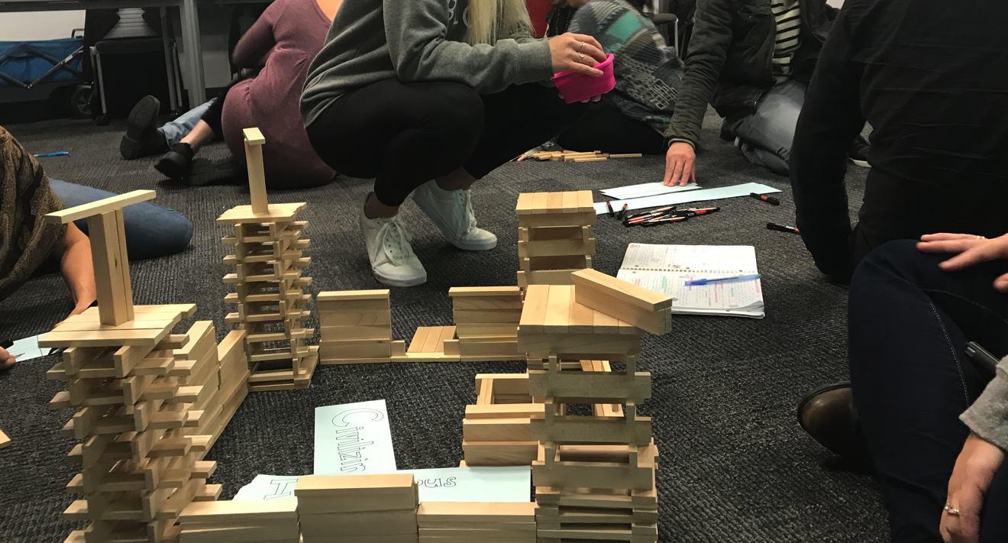
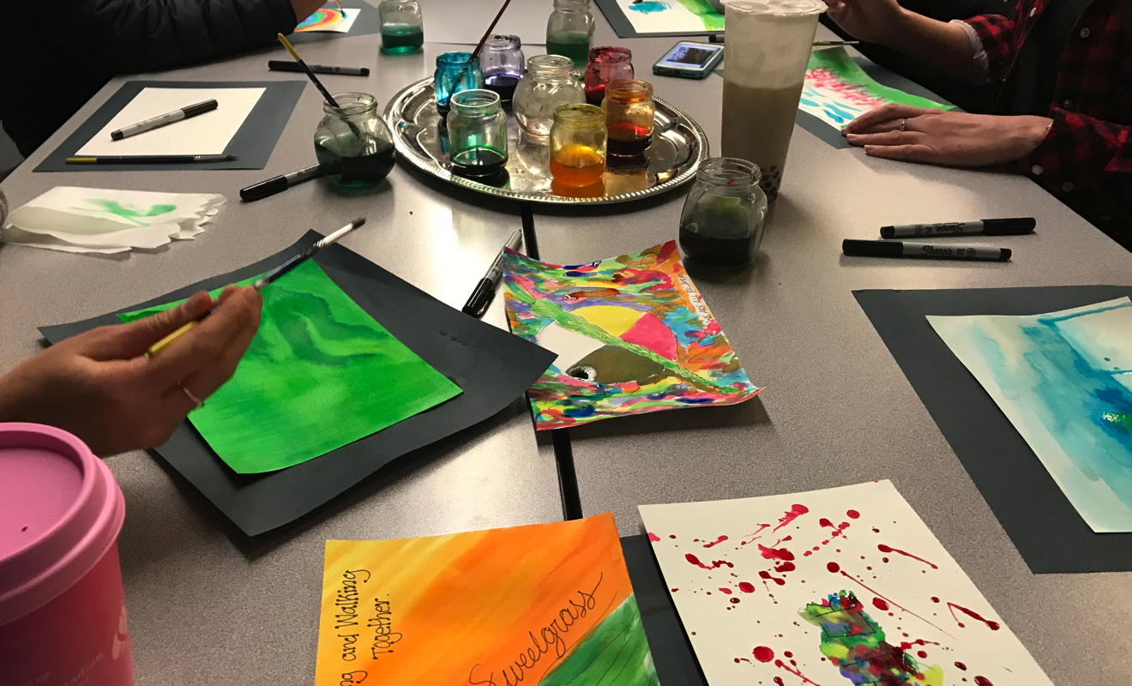
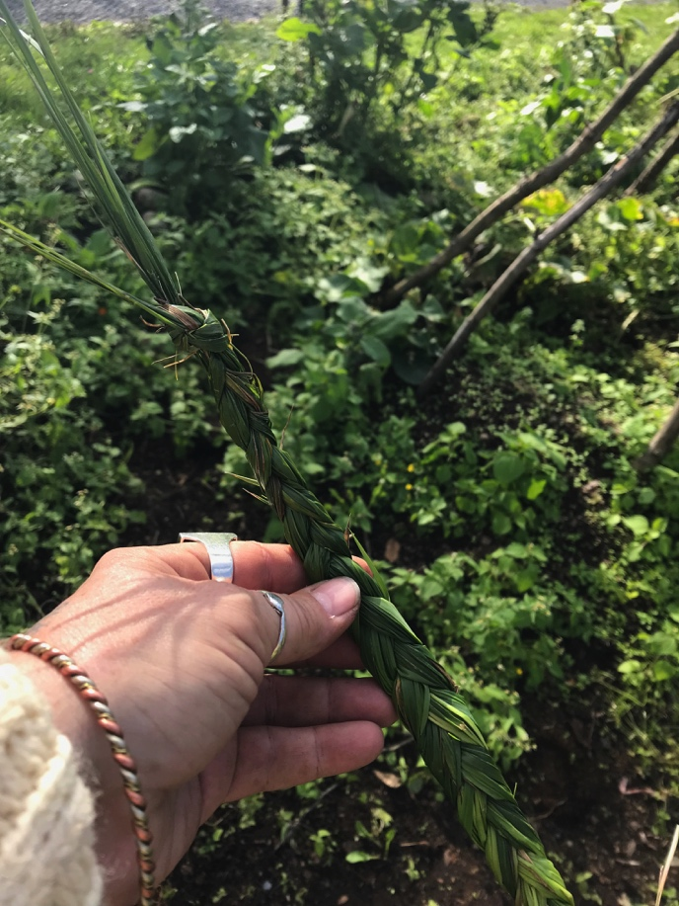
This does not mean that we relinquish the rigour of academic curriculum and resources in deference to exclusively play-based methodologies. Rather it offers students time to reflect and learn together as they weave discussions about readings and assignments with the collective work of art making projects, guided phenomenological art inquiry practices, and collaborative community building, each of which is also helpful in trauma informed pedagogy as well.

Conclusions

As the case grows for connecting students to the land on which they live, and ensuring their investment in maintaining the health of these places, shifting the focus in Environmental education to include non-Western scientific pedagogical paradigms such as Indigenous and Art-based education presents a powerful set of tools. Creating learning experiences that honour the holistic and interconnected nature of each of our students fosters the kinds of “brave space” conditions in which trusting relationships based on respectful honesty, empathy, and investment in protecting the earth to protect our collective future here.

References

Adese, J. (2014). Spirit gifting: Ecological knowing in Métis life narratives. Decolonization: Indigeneity, Education & Society, 3(3).
Bartlett, C., Marshall, M., & Marshall, A. (2012). Two-eyed seeing and other lessons learned within a co-learning journey of bringing together indigenous and mainstream knowledges and ways of knowing. Journal of Environmental Studies and Sciences, 2(4), 331-340.
Cajete, G. (1994). Look to the mountain: An ecology of Indigenous education. Skyland, NC: Kivaki Press.

Cajete, G. (1999). “Look to the mountain”: Reflections on indigenous ecology. In G. Cajete (Ed.). A people’s ecology: Explorations in sustainable living (pp. 2-20). Sante Fe, NM: Clearlight Publishers.

Carello, J. & Butler, L. (2015). Practicing what we teach: Trauma-informed educational practice. Journal of Teaching in Social Work. 35:3, 262-278.

Donald, D. (2009). Forts, curriculum, and Indigenous Métissage: Imagining decolonization of Aboriginal-Canadian relations in educational contexts. First Nations Perspectives, 2(1), 1-24.

Graham, M. A. (2007). Art, ecology and art education: Locating art education in a critical place-based pedagogy. Studies in art education, 48(4), 375-391.

Grady, M. (2006). Art and Consciousness—The Pedagogy of Art and Transformation. Visual Arts Research, 32(1), 83-91. Retrieved March 25, 2020, from www.jstor.org/stable/20715405

Greene, M. (1995). Releasing the imagination: Essays on education, the arts, and social change. Jossey-Bass.

Gruenewald, D. (2003). The best of both worlds: A critical pedagogy of place. Educational Researcher, 32(4), 3-12

Hutchinson, D. (2004). A Natural History of Place in Education. New York: Teachers College Press.
Joseph, R. P. (2018). 21 Things you may not know about the Indian act. Port Coquitlam, BC: Indigenous Relations Press.
Lowan-Trudeau, G. (2013). Indigenous environmental education research in North America: A brief review. In R. B. Stevenson, M. Brody, J. Dillon, A. E. J. Wals (Eds), International handbook of research on environmental education (pp. 404-407). NY,NY: Routledge.

Marin-Aguilera, B. (2018). Distorted Narratives: Morocco, Spain, and the Colonial Stratigraphy of Cultural Heritage. Archaeologies, 14(3), 472-500.

McLeod, N. (2000). Cree narrative memory. In Oral History Forum d'histoire orale.

Michell, H. (2018). Land-based education: Embracing the rhythms of the earth from an Indigenous perspective. JCharlton Publishing.

Regnier, R. (1994). The sacred circle: A process pedagogy of healing. Interchange, 25(2), 129-144.

Seawright, G. (2014). Settler traditions of place: Making explicit the epistemological legacy of white supremacy and settler colonialism for place-based education. Educational Studies, 50(6), 554-572.

Simpson, L. B. (2014). Land as pedagogy: Nishnaabeg intelligence and rebellious transformation. Decolonization: Indigeneity, Education & Society, 3(3), 1-25.

Smith, G.A. & Williams, D.R. (1999). Ecological education in action: On weaving education, culture and the environment. Albany, N.Y.: SUNY Press.

Sobel, D. (1993). Children’s special places. Tucson, AZ: Zephyr Press.

Vowel, C. (2016). Indigenous writes: A guide to First Nations, Métis, and Inuit issues in Canada. Portage & Main Press.

Wildcat, M., McDonald, M., Irlbacher-Fox, S., & Coulthard, G. (2014). Learning from the land: Indigenous land based pedagogy and decolonization. Decolonization: Indigeneity, Education & Society, 3(3).

